AOF Principles of Finance
Lesson 8
Investment Banking
Student Resources
Resource | Description
Student Resource 8.1 | Reading: Introduction to Investment Banks and Their Services
Student Resource 8.2 | Graphic Organizer: Cause and Effect
Student Resource 8.3 | Reading: History of Investment Banking

Student Resource 8.1
Reading: Introduction to Investment Banks and Their Services
New World Sounds is an established audio company that manufactures microphones, headphones, and audio accessories. The company has shown promise and growth over the past 10 years and is now looking for some ways to expand and increase its sales. Essentially, New World Sounds needs funds!
New World Sounds has an account at the local commercial bank. But they went to an investment bank to help them raise money. Why? What is an investment bank, and how it is different from the usual community bank?
What Is an Investment Bank?
An investment bank is a financial intermediary that performs a variety of services. Like a commercial bank, it helps people, companies, organizations, or even governments to find money when they need it. But they operate on a different scale.
Think about Hsin-I Chang, an engineer at New World Sound. If Hsin-I wants to buy a car, she might need $20,000. She goes to a commercial bank and gets a loan for $20,000. If New World Sound wants to expand to become a national or international company, the company might need $2 million or more. An investment bank offers different services to help New World Sound increase its capital, as the table below shows.
Investment Bank | Commercial Bank
Most common services offered:  - Helping wealthy individuals, companies, organizations, or governments to raise capital by issuing and selling securities (stocks, bonds, etc.) | Most common services offered:  - Checking accounts  - Savings accounts  - Auto loans  - Home loans
Although not every business will need to use an investment bank, issuing and selling securities can make raising a large amount of money much easier.
Capital-Raising Methods
Investment banks can help a company raise capital through equity financing. With equity financing, money is raised by selling stock, or a share of ownership in the company. New World Sound has never sold stocks before. It will have an IPO (initial public offering), where stock of the company is first introduced to the public. With the IPO process, a company decides to go public and then calls upon an investment bank to underwrite the offering. When people buy stock, they are buying a part of the company. If the company is a success, the stock will be worth more money. If the company fails, the stock will be worthless.
The investment bank could also sell bonds for New World Sound. A bond is a certificate of debt whereby the company promises to pay the holder a specified amount of interest for a certain amount of time. Buying a bond is loaning money to the company. The debt must be repaid on its maturity date or the date that the bond reaches its face value. Selling bonds is a type of debt financing—or raising money through the sale of bonds.
New World Sound is an established business, so investing in it is less risky. But what if Hsin-I, New World Sound’s engineer, decides to launch her own business to create a new type of headphones? That might be very risky. There are already lots of good headphones on the market, and while Hsin-I knows a lot about engineering, she doesn’t have a proven track record for running a business. A traditional investment bank might not be able to help Hsin-I, but a venture capital firm might. Venture capital is money provided by venture capitalists to start-up firms and small businesses. Due to the high risk involved with funding new start-ups, the expected return can be quite high. Venture capital is an important source of funding for new businesses that are not able to acquire the funding through primary lenders.
Mergers and Acquisitions
Aside from raising capital, investment banks also help to bring separate companies together to form larger ones and break up large companies to form smaller, more specialized ones. These services are generally referred to as mergers and acquisitions.
- When one company takes over another company, the purchase is referred to as an acquisition. If New World Sound buys Hsin-I’s small company, they have acquired it.
- A merger happens when two firms agree to combine and form one company. With a merger, both companies’ stocks no longer exist and a new company stock is issued. For example, on July 29, 2008, two satellite radio services, Sirius and XM, completed a merger to create a single satellite radio network, Sirius XM Holdings.
During mergers and acquisitions, both companies would enlist the help of an investment bank to mediate the process. The investment bank would offer financial advice and research the value of the company. Accurately researching the value of a business is one of the most important aspects of mergers and acquisitions, since this information will impact what the company will be sold for. Mergers and acquisitions can be worth millions of dollars and can generate huge profits for both companies as well as the investors that are involved.
Types of Investment Banks
Investment banks can come in many different styles and sizes, and this aspect of the industry seems to be constantly changing. For example, today there are some very large banking companies that include both commercial banks and investment banks. These are called financial holding companies. A financial holding company is a financial institution that typically owns one or more banks and is regulated by the Federal Reserve Board.
How did these financial holding companies get created? You may have heard people talking on the news about the banking crisis of 2008, which was part of the economic downturn we have all experienced over the last several years. One result of that crisis was that many investment banks had to be bought out by commercial banks. Financial holding companies were created so that they could offer all the usual banking services of a commercial bank as well as the investment services of an investment bank. The Bank of America Corporation and Wells Fargo Company are examples of financial holding companies.
Finally, the term boutique banks refers to very small investment banks that don’t typically provide full investment banking services but specialize in a certain area of investment banking. For example, a boutique bank may concentrate in a specific geographical area or specialize in investment services for technology companies.
Investment banking plays a crucial role in our society. Companies, business owners, individuals, and even the government rely on the service investment bankers provide. Although investment banks may disappear, the investment banking function performed by banks most likely will not.

Student Resource 8.2
Graphic Organizer: Cause and Effect
Student Name:_______________________________________________________ Date:___________
Directions: As you listen to the presentation on the history of investment banking, use the following cause-and-effect chart to help you organize your notes. Remember, you may use this graphic organizer as a study guide as you prepare for your short-answer quiz at the end of the lesson.
Event #1

Event #2

Event #3

Event #4

Student Resource 8.3
Reading: History of Investment Banking

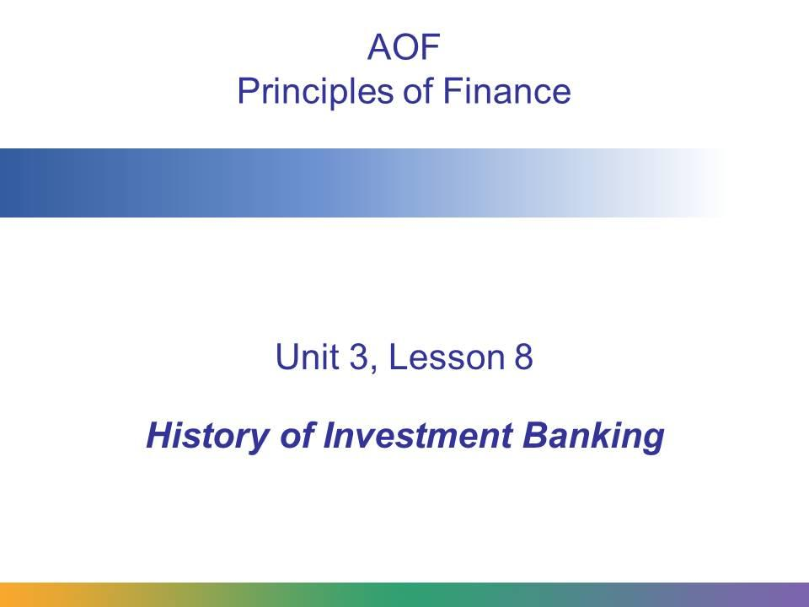
Throughout the years, the investment banking industry has seen many changes. It began as as a form of government financing; today it is primarily focused on complex approaches to raising capital.
The health of the investment banking industry affects individuals, businesses, and even the government. Many of the changes made to the investment banking industry are a result of major events, like a global stock market crash or a bankers’ panic. However, if a major company fails, an industry has a downturn, or a bank engages in fraudulent practices, it can affect the entire industry.
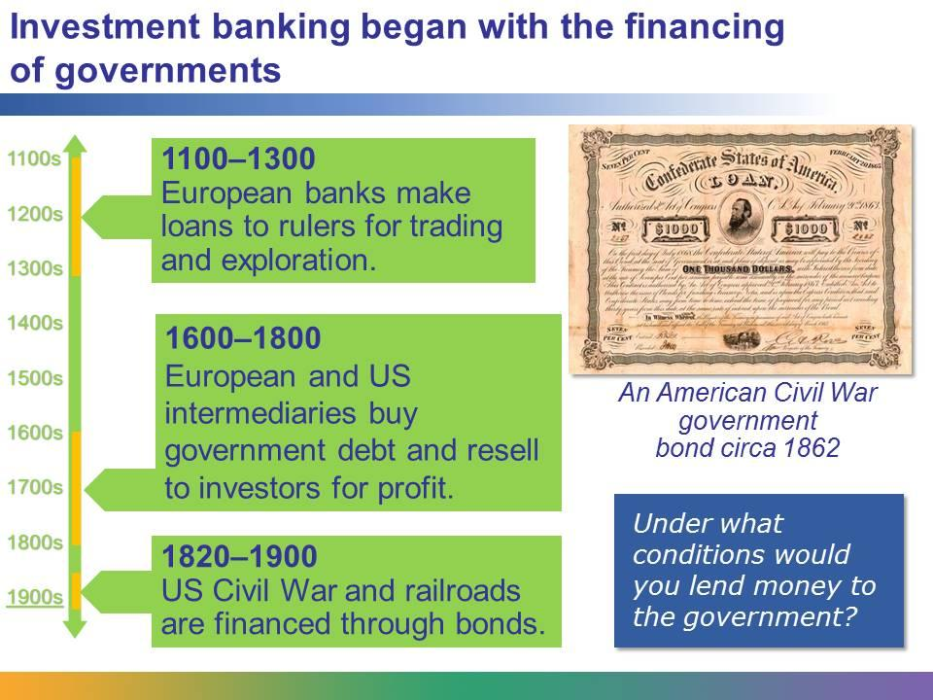
Some of the earliest investment banking practices began in Europe.
During the 12th and 13th centuries, European banks made long-terms loans to various rulers. In the 1300s, Florence, Italy was a banking hub. King Edward III borrowed vast sums of money from the great banks of Florence to fund his war with France. He could not pay the money back, and the three biggest banks in Florence collapsed.
During the 18th century, intermediaries bought government-issued debt and then resold it to investors at a profit. This process soon spread to the United States, where investment bankers quickly copied the practice.
In the early 19th century, the financing of US railroads was dependent upon this investment method, which involved mainly investors overseas as well as wealthy US traders and ship owners.
The American Civil War was financed by the selling of millions of dollars in government bonds.
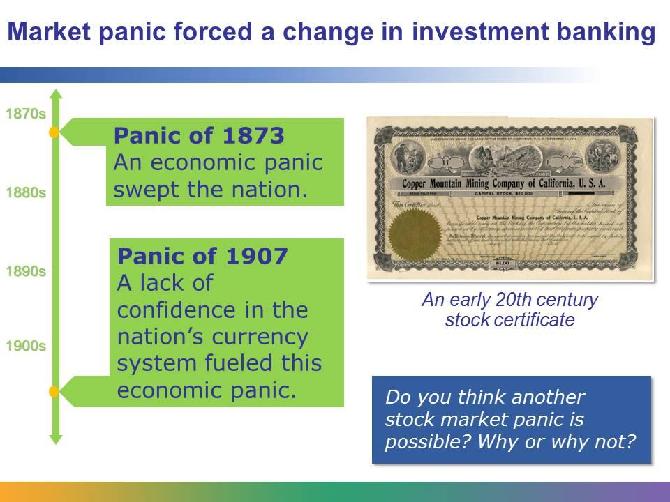
The Panic of 1873 began with the failure of a prominent investment firm located in Philadelphia called Jay Cooke and Company. The company speculated, which means they took a risk to try to make more money. Their speculation failed and the firm went bankrupt, along with several other commercial and investment banks. The stock market closed for 10 days, and within the next two years 18,000 businesses failed.
There were many causes that ultimately led to the Panic of 1907, but one of the main causes was the failed attempt by bank owner F.A. Heinze to manipulate the price of a company’s shares. When his attempt failed, the stock market crashed, causing a panic, which led to “runs” on banks across the nation. In other words, businesses and individuals all tried to withdraw their money at the same time. This run caused banks to collapse, the stock market to crash, and businesses to fail.
Due to these events, many people realized the need for creating a mechanism for maintaining stability within the industry, and a centralized banking system was established.
The image on the slide is of a 1919 stock certificate for the Copper Mountain Mining Company of California. Even today when you purchase stock in a company, you’ll receive a certificate that states your ownership share.
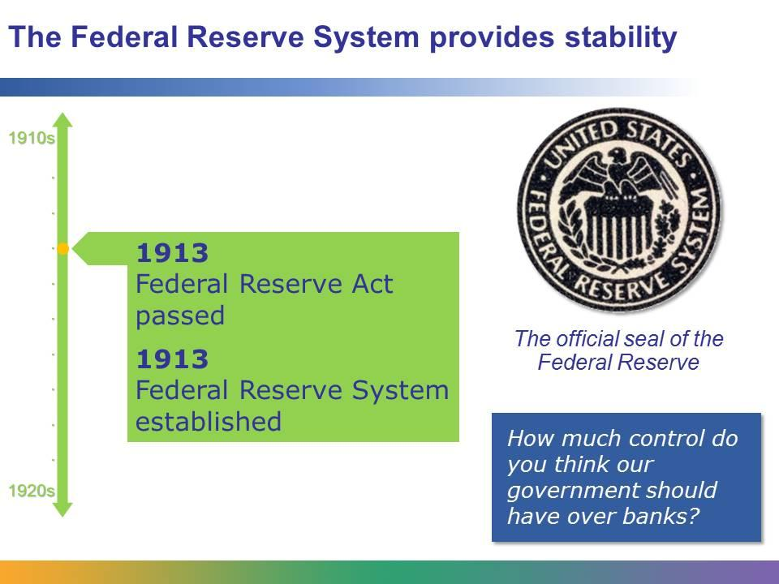
In 1913, Congress passed―and the president signed―the Federal Reserve Act, which increased government oversight of the financial system. The Federal Reserve Act created the Federal Reserve, the central banking system of the United States. The Federal Reserve comprises 12 privately owned Federal Reserve Banks, which are located throughout the nation.
One of the main functions of the Federal Reserve is to help control and manage the nation’s monetary supply. In other words, as the economy grows and expands, the monetary supply should expand to support it.
The Federal Reserve also created a nationalized check-clearing system. During periods of economic instability, many banks refused to cash and clear checks from other banks.
Finally, establishing the Federal Reserve created a bank that could provide the government and other banks the specific financial services that they need. The Federal Reserve helps to create confidence among borrowers and lenders and helps to support a more stable and efficient national monetary system.

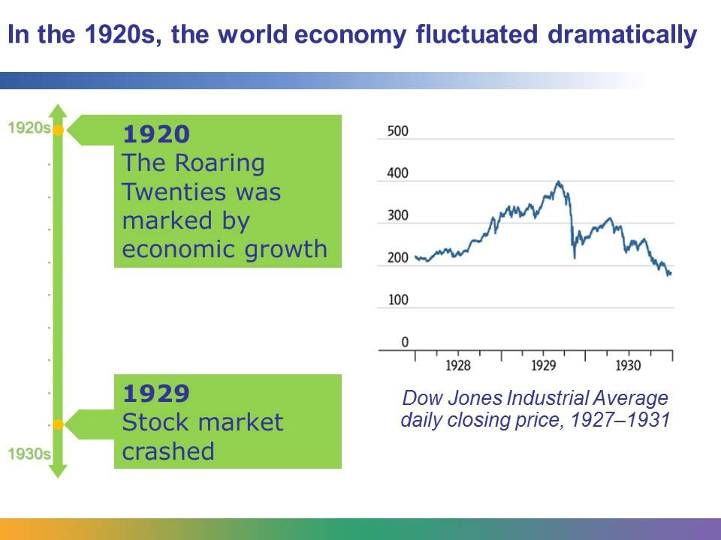
Both commercial banks and investment banks expanded during the 1920s. Everyone wanted to invest in the stock market. Banks began issuing securities and placed huge sums of money into this branch of their business. Consumer spending and credit sales were high. The US economy became dependent on investments from the wealthy.
During this time there were few regulations placed on investment firms and brokers. Many brokers and bankers were privy to inside information that was not available to the general public. Investors were searching for huge returns on their investments, which led to widespread market speculation. Investors took big risks on their investments but expected big profits.
Although there were many causes of the Great Depression—which lasted most of the 1930s—one of the main ones was the stock market crash of 1929. The stock market crash created a lack of public confidence in the government and businesses across the nation. Stocks dropped to 20% of their value. Consumers stopped purchasing goods and people lost their jobs. Banks became conservative with their lending and struggled to survive. As banks failed, people simply lost their savings. Imagine if all the money you and your family had was suddenly gone—not because you did anything, but because the bank had gambled with your money.
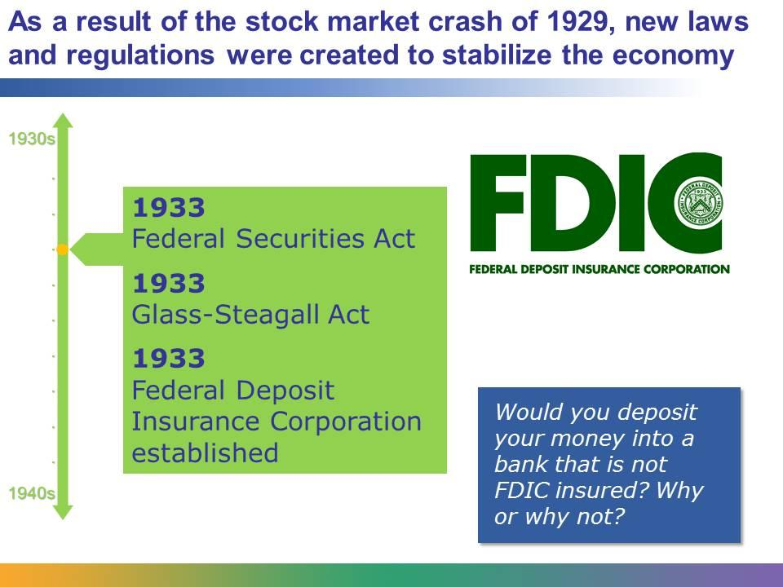
The Federal Securities Act was the first major federal law about the sale of securities. This law requires the issuing company (the one offering securities for sale) to provide investors with information about the securities so that they can make informed decisions related to their investments.
The Glass-Steagall Act made many changes in commercial and investment banking. Even more importantly, it established the FDIC (the Federal Deposit Insurance Corporation). The FDIC guarantees the safety of a consumer’s deposit, up to a certain amount. Today, a consumer’s account is guaranteed up to $250,000.
Because of the number of bank failures during the Great Depression, the government understood the need to restore the public’s confidence in the banking system. With the FDIC established, depositors could be confident that their money was safe as long as they were banking at an FDIC-insured bank.
Between the 1930s and the early 21st century, the banking industry continued to change and evolve in many ways.
In the early years of this century, housing prices were rising. Eager to make money, mortgage lenders began accepting risky subprime mortgages, meaning that they were lending money to individuals with lower credit ratings or a poor credit history. To offset this risk, many commercial banks sold these loans to other banks, including investment banks.
Many investment banks decided to accept this risk, because in exchange for the higher risk, the borrower was paying much more in interest. However, in 2008, subprime mortgages began to fall apart. People couldn’t pay their loans, home prices dropped, and home foreclosures soared. Thus, a number of investment banks that invested in subprime loans incurred millions and billions of dollars of losses. These losses ultimately created a worldwide financial crisis commonly known as the subprime mortgage crisis.
As you already learned, the investment banks that suffered during the subprime mortgage crisis were taken over by financial holding companies, which combine the services of investment banks and large commercial banks.
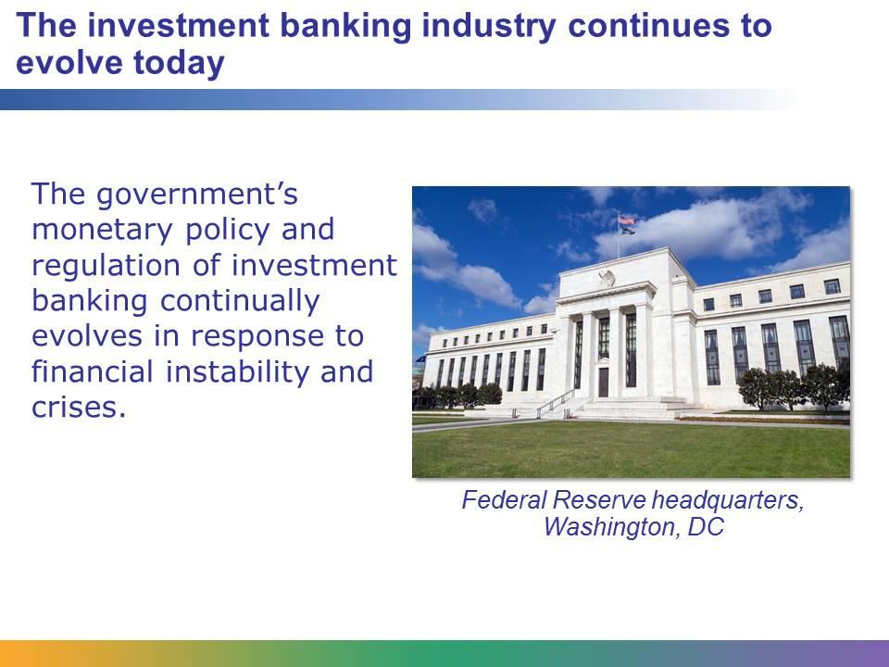
The investment banking industry is still experiencing many changes today. Dramatic changes, such as the subprime mortgage crisis, seem to surprise and shock society. But when we take a closer look at some of the historical events that the industry has survived, we can begin to accept these changes as a part of the constant evolution of the industry in general. The government’s monetary policy and regulation of investment banking continually evolves in response to the various financial instabilities and crises.

